RELAYS 1
The basis for relays, is the simple electromagnet
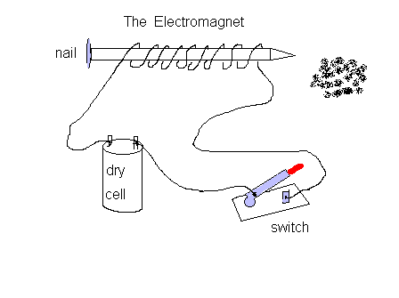
A nail, some wire, and a battery is all that is needed to make one,
to demonstrate and amaze your small children..add a switch, and presto! You're the talk of the town.
With no power applied to the coil, the nail is NOT magnetized
Connect this to a power source, and it will now grab and hold small pieces of metal.

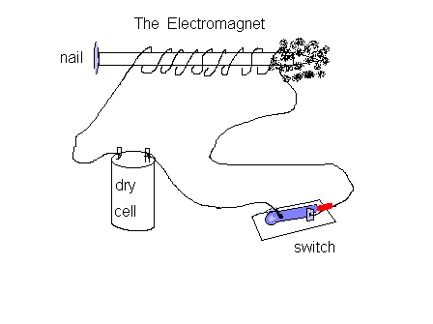
So, herein lies the concept. If we take an electromagnet, it will interact with metals in its vicinity. now lets take this one step further... If we were to place a piece of metal, near the electromagnet, and connect some contacts, so that when the electromagnet is energized, the contacts close, we have a working relay.
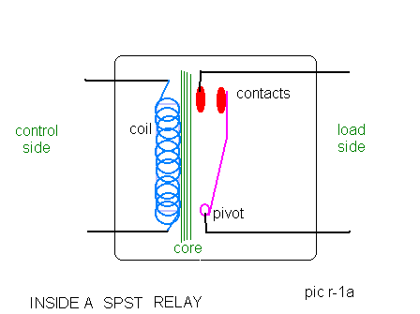
The simplest relay, is the Single Pole, Single Throw (spst) relay. It is nothing more than an electrically controlled on-off switch. It's biggest property, is the ability to use a very small current, to control a much larger current. this is desireable because we can now use smaller diameter wires, to control the current flow through a much larger wire, and also to limit the wear and tear on the control switch.

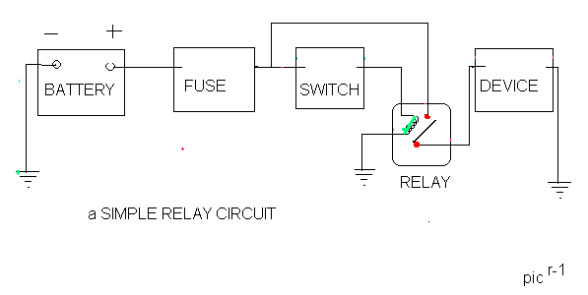
Above is a simple relay control. Now, here is what is happening.....
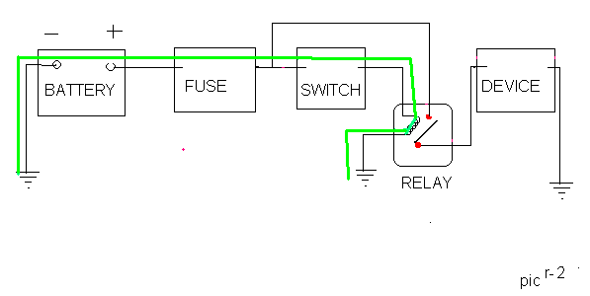
The control circuit (GREEN) powers the coil inside the relay, using a small amount of current. It flows from the battery, thru the fuse ( for protection) to a switch, (say, a light switch) then to the coil in the relay, energizing it.

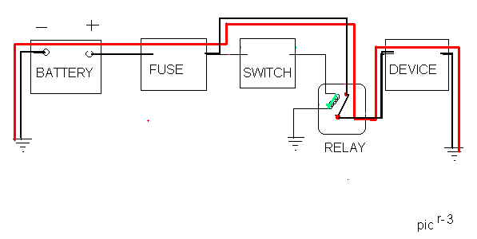
The coil, now energized becomes an electromagnet, and attracts the metal strip with the contacts, which closes, providing a secondary heavy current path ( RED ) to the device ( say, the fog lights)
Turning off the switch, opens the circuit to the coil, removes current flow, and the electromagnet is no longer a magnet, the secondary path is opened, and the lights extinguish

